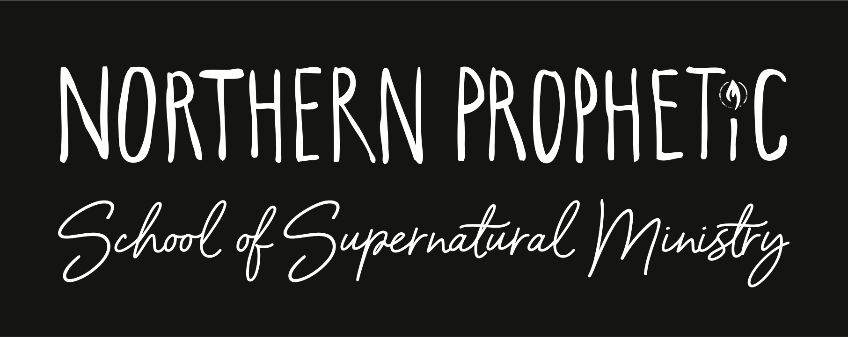
OFFICE USE ONLY
Date received
Application fee
Early bird
Multi-family discount
Collective
since 2016 Registered Charity no.1167142
Please email a picture of yourself that is a current
likeness to info@npssm.org
Do not include anyone else
in the photo.

Application Form
Second Year

Thank you for your interest in Northern Prophetic School of Supernatural Ministry.

NPSSM is a nine-month school committed to equipping and empowering you to passionately pursue world transformation in Jesus’ name.

NPSSM is not for the faint hearted. We expect students to hungrily seek the presence of God, to chase after breakthrough and wholeheartedly desire to see the Kingdom of God released through them and the people around them.

Our school structure is founded on freedom and honour rooted in love. We encourage growth through feedback and a culture of wisdom through creativity, excellence and integrity. Throughout the year you will be invited to join in Advance Ministry Training Sessions, Bible study, Retreats, Social Events, Outreaches, Guest Speakers, plus excellent teaching with our BSSM curriculum, small revival group mentoring and homework programme.*

Tuition for the full year is £400 per person**. The school will be on Thursday evenings from 6.30pm*** beginning mid-September until June, and will mirror the local school terms.
If you feel that Holy Spirit is calling you to NPSSM, please complete and return this application form along with your £35 application fee and your picture. If your initial application is approved, you will hear from one of the leadership team to set up an interview.
Get ready!
Abundant joy,
The NPSSM Team.
*Subject to restrictions.
**Early bird, multi-family and group discounts available.
***Exact time subject to change.
All information provided will be kept confidential and used in accordance with GDPR 2018.
Only NPSSM leadership will have access to any personal information provided.
Personal Information
Your name

Street

Town

County Postcode

Email

Phone number Gender

Age Date of birth

Place of birth Are you a UK citizen? (please delete) Yes / No

If “No”, what is your country of citizenship? (please note, we cannot accept applications from those who do not have the right to reside in the UK)

If not English, what is your first language?

On a scale of 1 to 5 (5 being the highest), how good are your reading skills in English? (please circle)
1 2 3 4 5

On a scale of 1 to 5 (5 being the highest), how good are your writing skills? (please circle)
1 2 3 4 5
While a great deal of School life is spent face-to-face and hands-on, nearly all the homework is normally handed out and handed in online. Do you have internet access with which you can watch online videos, and receive, edit and send simple documents? Yes / No
If ‘no’ please indicate how you will manage this (e.g., “I can do it at a friend’s house…”)

About your first year…
We welcome second year applications from students who have undertaken the first year of studies at a
School of Supernatural ministry other than NPSSM.
Where did you undertake your first year?

What dates were you there?

Who was your Course director or Revival Group leader?
(Non-NPSSM) Can we contact them? Yes / No …. If ‘yes’ please add a contact detail
Family
Are you currently… (please tick)
Single Married Separated Widowed Divorced In relationship Engaged
If married, will your spouse be attending NPSSM? (please delete) Yes / No

Name of spouse if married

Names and ages of any dependent children

Please give details of any other same household family member attending or applying for NPSSM

Spiritual Information
How and when did you receive Jesus Christ as your Lord and Saviour?

Have you been baptised in the Holy Spirit according to Acts 1:8 and Acts 2:4? If so, when?

Name of the Church you are part of

Senior Leader’s name

Church street

Church town

Church postcode

Church email

How long have you attended this Church?

Have you changed Church in the last six months? (please delete) Yes / No

If ‘Yes’, how were things left in the relationship between yourself and the leaders of the Church?

What Christian service/mission have you have done?

Which spiritual gifts would you say you currently operate in? (See 1 Corinthians 12:7-11 and Romans 12:6-8.)

How would you describe your personal relationship with God at the present time?

Education
What is your highest educational level?

What was your area of study?

Have you received any other training or valuable learning experience?

What is your attitude to being monitored and lovingly corrected when necessary?

How important to you is getting your homework in on time and why?

Describe yourself as a student

Employment
Are you currently in paid employment? (please delete) Yes / No

If yes, what is your occupation?

Health information
Please describe any physical or emotional conditions, and state any special attention, treatment
or medication required

How would others describe your temperament?

Experiences
We value honesty and answering “YES” to any of these questions will NOT automatically disqualify you from acceptance to NPSSM.
Do you have any life controlling issues or addictions that you are struggling with
(e.g. smoking, drugs, alcohol, eating disorder, pornography)?

Have you been convicted of any crimes (other than speeding offences)?

Have you been involved in the occult, witchcraft, or cults? If so, please provide a brief explanation

How important is purity to you and how do you pursue it?

More information
How did you hear about NPSSM? (please check any that apply and give details)
Friend Family member Leaflet At church Other (please state)

Why are you applying for the Second Year of NPSSM?

What are you hoping to get from the Second Year of NPSSM?

Are there areas of ministry that you feel most called to and why?

What are you really passionate about?

What are your top three core values?

In order to maintain your place in school, all payment deadlines must be reached and full fees are required by December after the course has commenced. How do you intend to pay for NPSSM? (Please do not allow someone else to pay 100% of your fees; this is about faith, value and commitment.)

Please provide three recommendations; people we can approach for a reference.

Pastoral recommendation (normally your Church leader)
Title & Full Name

Phone number

Email

First personal recommendation
Title & Full Name

Phone number

Email

Second personal recommendation
Title & Full Name

Phone number

Email

Tuition fees
NPSSM full tuition fees are £400.
If this form is received by 30th June you qualify for the Early bird discount of £50.
If you invite someone to NPSSM, they apply and pay their deposit before 30th June you receive a free book that will be required for NPSSM.
Couples discount: There is a discount for couples joining NPSSM receiving £50 off a joint application outside of the Early Bird date.
‘Collective’ bookings: 10% discount for groups of 5.
We require a non-refundable £35 application fee with this form which will be deducted from the balance of your tuition fees upon acceptance into the school.

Please indicate how you will be paying:
CHEQUE - Make payable to ‘Northern Prophetic School of Supernatural’
Post to NPSSM, 40 Hartburn Ave, Stockton on Tees, TS18 4EX
CASH
BANK TRANSFER - Northern Prophetic School of Supernatural
Sort Code: 09-01-28 Account Number: 90767509
Payment terms
We will confirm your acceptance to NPSSM by letter and to secure your place and start the course,
we require the initial deposit payment of £150 due by, or on, the enrollment date in September.
You can pay your tuition fees in full or in three installments as follows:
£70 due on the first Thursday in October.
£70 due on the first Thursday in November.
£75 (or the balance if you qualify for Early bird, couples or collective discount) due on the first Thursday in December.
All tuition fees are due in full by the first Thursday in December.

Agreements and data protection consent (please tick boxes)
I understand that falsification of information on this application is grounds for dismissal at any time
I understand that to continue in the school it is my responsibility to meet payment deadlines
I consent to NPSSM to take photographs or video of me and for them to be used in NPSSM
promotional material and publicity. This might include (but is not limited to), the right to use
them in their printed and online publicity, social media, press releases and funding applications
I agree to minister in a manner consistent with the NPSSM core values *
I hereby give permission for Northern Prophetic School of Supernatural Ministry (NPSSM) to process and use my personal details as given in this form, in compliance with the EU’s General
Data Protection Regulation (2018) and NPSSM’s Data Protection Policy *
I hereby give permission for NPSSM to retain my basic contact details beyond my time of study in order to maintain a list of Alumni and to let me know about connected events.

Signature

Date

Please print name

* Available on request. Please contact info@npssm.org

Please return this form along with a picture of yourself and your application fee to:
NPSSM, 40 Hartburn Ave, Stockton on Tees, TS18 4EX

info@npssm.org August 2023

